**Requirement:**

**Relevance to Sustainable Development Goals**

<https://sdgs.un.org/goals>

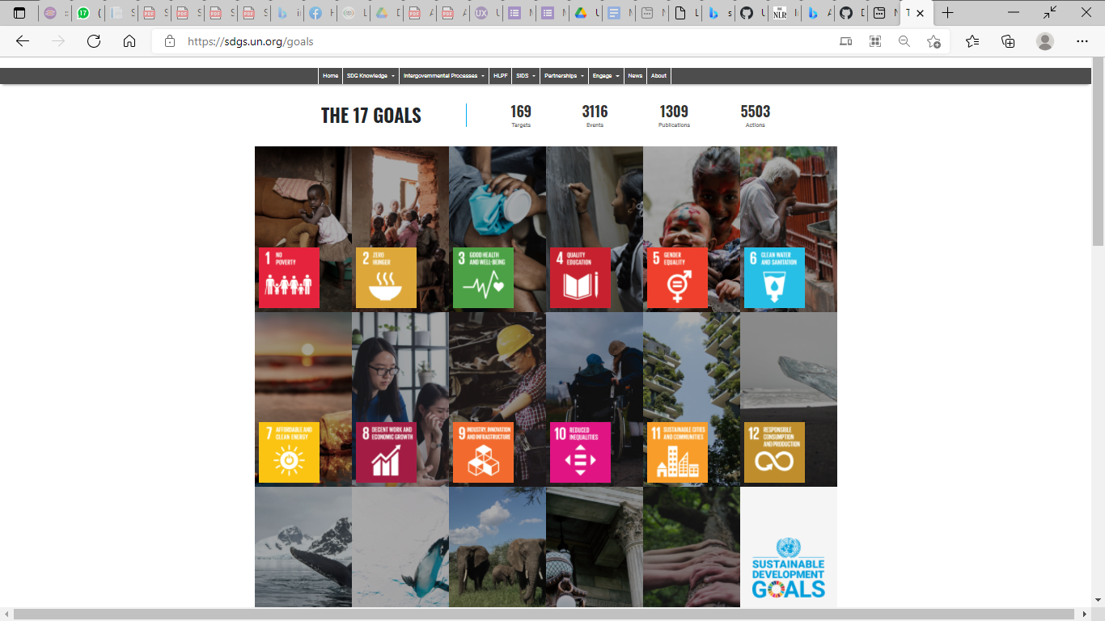

**Approach taken for development of Aajeevika:**

The objective of the application is to improve and increase the outreach of their farm and non-farms products. Using the Aajeevika mobile app, rural women get connected  with potential buyers of their products  and  government can  monitor the activity on LIVE dashboard of web version of this application. In addition to this, the application also provides comprehensive livelihoods promotions information to the rural women such as information on mechanism to apply for government schemes and programmes for livelihoods promotions, videos gallery with skilling and motivational videos, success stories of rural entrepreneurs, government notifications on livelihoods promotion etc.

Aajeevika platform caters to two SDG  goals – “**SDG 1 :No Poverty**” and “**SDG 8: Decent Work and Economic Growth**”. The Application contributes to SDG goal 1 as its objective is to improve the outreach of the products being sold by rural women for profit maximization which is envisaged to improve their financial status and help them to get out of poverty. It also contributes to SDG goal 8 as the app will  support  rural women owned micro rural enterprises used for  manufacturing marketable farm or non-farm products; this in turn  will lead to local economic growth and employment opportunities.